Dalton Murray

Human Computer Interaction

INT 3603 - 3452-202320_INT3603_OL

Professor Darren Hood

Sunday, April 9, 2022

**Assignment 4**

The website which I have chosen to run the aXe accessibility test on is Reddit.com. Reddit is one of the world’s most popular websites exceeding over a billion, nearly two billion, visits a month. This means that it should be extremely accessible and should not have any accessibility issues. Unfortunately, however, with the aXe tool there was a large number of accessibility problems which it was able to find.

aXe

There was a total of 107 accessibility violations on Reddit. This goes to show that even popular, large websites are not immune to having significant accessibility violations and issues.

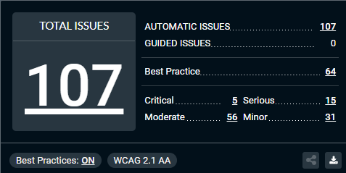

These accessibility violations are broken down as follows:

Critical – 5:

Certain ARIA roles must be contained by particular parents - 1

Buttons must have discernible text – 2

Images must have alternate text – 2

Serious – 15:

Elements must have sufficient color contrast – 6

Links must have discernible text – 9

Moderate – 56:

Heading levels should only increase by one – 1

Document should have one main landmark – 1

All page content should be contained by landmarks – 54

Minor – 31:

ID attribute value must be unique – 23

ARIA role should be appropriate for the element – 8

Looking more closely at these issues I am able to find a number of things which would impact someone who has accessibility issues. Firstly, some buttons do not have any text on them, if someone were to use a screen reader on this they would not know what the button does, secondly, not all images have alternative text. Alternative text is extremely important for people who use screen readers, however, because of how Reddit works this may be the users fault and not the fault of Reddit, as the user would have to put in an alternate text. It is possible, however, for Reddit to enforce on users that they need to put an alternative text if they post an image. Looking further, a lot of elements blend in with each other which is impacting its color contrast which would significantly limit the ability for colorblind people using the website. Continuing, some links don’t have a discernible text which would also interfere with screen readers. Looking into moderate now, there is not too many issues here other than not everything is really in landmarks which could also make it problematic for screen readers. Finally, moving to the minor section. There are 23 counts of ID attributes not being unique, I would not classify this as minor and would classify it as serious. Screen readers may often use these ID’s and read them to the person using the screen reader, if it repeats the person using the screen reader may lose track of where they are on the page or think something is wrong.

Overall, I would have to give Reddit a score of 6 on accessibility. They do not seem to focus on accessibility that much. However, for testing purposes, I ran a screen reader on the website and it seemed to handle alright and I was able to quickly navigate the page without many issues despite the large number of violations. Despite this, I only really tested it for roughly 15 minutes, so a person using it for a larger amount of time may run into many more problems than I did. I believe because of the large number of accessibility violations, however, that a large number of people would be impacted by this. As a result of this, Reddit may lose users who have accessibility issues such as being blind or colorblind which may significantly impact their business. It is also possible that because of how Reddit works if someone were to post about these accessibility issues then even people who do not have accessibility issues would leave the site until they fix it, which I believe to be a good thing, but bad for Reddit.

**References**

Kim, G. J. (2015). Human-Computer Interaction: Fundamentals and Practice. Auerbach.

I have neither given nor received unauthorized aid in completing this work, nor have I presented someone else's work as my own.

*Dalton Murray*